SCOTT COUNTY PUBLIC SCHOOL HEAD START

305 LEGION STREET WEBER CITY, VIRGINIA 24290

PH.: 276-386-6051

FAX: 276-386-7281

*Cindy Raymond, Director*

# Mitigating the spread of Covid-19 in Head start programs

**Purpose:**

The purpose of this policy is to provide guidance to Scott County Public School Head Start (SCPSHS) around the final rule, mitigating the spread of COVID-19 in Head Start Programs.

The final rule effective January 6, 2023, removes the universal masking requirement for individuals 2 years and older. It does not address the vaccination requirement, therefore the Head Start Program Performance Standards (HSPPS) at 45 CFR 1302.93 and 1302.94 remain in effect. The final rule also requires Head Start programs to have an evidence-based COVID-19 mitigation policy, developed in consultation with our Health Services Advisory Committee (HSAC).

SCPSHS’s priority is to implement the protocols needed to promote the safety of in-person learning environments for staff, contractors, volunteers, children, and their families.

**Scope:**

This policy applies to all staff, and contractors whose activities involve contact with, or providing direct services to children and families, and volunteers working directly with children of Scott County Public School Head Start. All individuals covered by this policy are required to follow the measures hereby listed in this policy to reduce or lower SARS-CoV-2 transmission, or disease severity when community spread increases. Therefore, ensuring our program adapts to changing circumstances and conditions of COVID-19. The evidence-based migration policy will enact multiple strategies, using a layered approach to minimize the impact of SARS-CoV-2 to protect the health of children, families, and staff. This policy also includes a specific communication plan on how information is relayed to staff, families, and children of the program.

**Authority:**

Guidance for this policy is supported by (88 FR 993) contained within the Code of Federal Regulations 45 CFR Part 1302.47(b)(9) – MITIGATING THE SPREAD OF COVID-19 IN HEAD START PROGRAMS; Head Start Program Performance Standards; and the program’s Personnel Policies & Procedures Manual.

The revised standards (Amendment to 45 CFR Part 1302.47) as follows:

**PART 1302 – PROGRAM OPERATIONS Subpart D – Health Program Services 1302.47 Safety practices.**

(9) COVID19 mitigation policy. The program has an evidence-based COVID-19 mitigation policy developed in consultation with their Health Services Advisory Committee (HSAC) that can be scaled up or down based on the impact of COVID-19 in the community to protect staff, children, and families from COVID-19 infection.

**Universal Strategies for Everyday Operations**

SCPSHS will take a variety of actions every day to mitigate the spread of infectious diseases, including the virus that cause COVID-19. The following strategies are universal strategies that will be in place during everyday program operations and all COVID-19 community levels, including low.

**Staying Up to Date on Vaccinations**

All staff or contractors whose activities involve contact with or providing direct services to children and families, and volunteers working directly with children of SCPSHS are required to be fully vaccinated. For more information on SCPSHS’s mandated vaccination policy see the amended COIVD 19 Vaccination Policy.

SCPSHS will promote equitable access to vaccines to staff, families, and children through current recommendations and information outlined by the CDC. SCPSHS will partner with the local Health Department and the Health Wagon to schedule and promote onsite vaccination clinics as advised, and will provide information, where available, regarding off-site vaccination locations. It is the stance of SCPSHS to provide information about COVID 19 vaccines as well as other childhood immunizations, and will provide staff paid time off to receive COVID 19 immunizations and related boosters. More information on the COVID 19 immunization schedule can be found at: <https://www.immunize.org/catg.d/p3130.pdf>

**Staying Home When Sick**

Any person with symptoms of a contagious infection such as cough, fever, sore throat, vomiting, or diarrhea, should stay home. Any child or staff member with a fever of 100.4 or greater will be excluded from center activities. Testing is recommended for anyone with symptoms of COVID 19 as soon as possible after the onset of symptoms. Staying home when sick can lower the exposure and infection rates of COVID 19 as well as other infectious diseases. For more information on when exclusion from center care is necessary, please see “Is your child well enough to be at school today?” attachment at the end of this policy.

**Hand Hygiene and Respiratory Etiquette**

SCPSHS will teach and reinforce proper hand hygiene to lower the risk of spreading viruses. Staff will monitor and reinforce handwashing behaviors during key times of the day such as before and after eating, after using the restroom, when visually soiled, and after outdoor play. Staff will also wash hands during these key times of the day as well as before and after diaper changing or assisting the child in the restroom. All classrooms will be provided with handwashing infographics on or near handwashing facilities. All centers will be provided proper handwashing materials such as soap, water, and paper towels where possible and when proper handwashing is not accessible, hand sanitizer with a minimum of 60% alcohol will be available for all children, ages 2 and up, and staff. Staff will teach and monitor proper respiratory etiquette through the provisions of covering a cough or sneeze and the proper way to use, handle, and discard tissues to help keep individuals from getting and spreading infectious diseases. For more information clink the link to be directed to the CDCs video for “Cover Your Coughs and Sneezes-Kids.” See also the attachments at the end of this policy.

<https://youtu.be/mQINuSTP1jI>

**Ventilation**

SCPSHS will optimize ventilation and maintain the air quality improvements as provided by the current air purifier in place, iWave. Maintenance and updates such as routinely changing filters will be provided as needed. Staff will be encouraged to open windows when safe to do so to allow for circulation of fresh air. During increased levels of community transmission, such as medium and high as determined by Virginia Department of Health (VDH), education staff will be encouraged to provide more classroom activities outdoors, weather permitting.

**Cleaning**

All classroom surfaces will be cleaned and sanitized with the use of the electrostatic disinfecting handheld sprayer at least once daily to reduce the risk of spreading germs. Additionally, classroom staff will follow the recommended procedures for cleaning, sanitizing, and disinfection in their settings such as after diapering, feeding, and exposure to body fluids. More information can be found in “Safety” center procedures section B.

**Increased COVID 19 Levels and Associated Prevention Strategies**

The Virginia Department of Health’s COVID-19 date tracker helps communities and individuals make decisions about COVID 19 prevention strategies utilizing key data. This data categorizes a community’s level of transmission as low, moderate, or high. During increased or particularly high levels of transmission and outbreaks, SCPSHS will take additional prevention strategies as necessary. When COVID 19 Community levels begin to decline, SCPSHS will consider reducing layered prevention strategies with continual monitoring. The following data tracker will be utilized to determine Scott County, Virginia’s community level:

<https://covid.cdc.gov/covid-data-tracker/#county-view?list_select_state=Virginia&data-type=CommunityLevels&list_select_county=51169>.

Any individual of SCPSHS who is at risk for severe sickness when contracting COVID 19 will be given reasonable modifications and accommodations when necessary to ensure that all children, including children with disabilities, are able to access in-person learning. SCPSHS will follow the CDC’s list of who is at risk for getting severely ill. More information can be found by navigating to the CDC link below.

<https://www.cdc.gov/coronavirus/2019-ncov/your-health/risks-getting-very-sick.html>

**Low Community Transmission Level**

SCPSH will follow the universal strategies for everyday operations and will continuously monitor the Virginia Department of Health’s transmission data tracker.

**Medium Community Transmission Level**

*Masking:* Any staff, child, or family member of SCPSHS who chooses to wear a mask will be supported in their decision regardless of community level. During increased medium community level transmission, immunocompromised individuals ages 2 and over should wear a high-quality mask or respirator when indoors or in a public setting.

*Diagnostic Testing*: SCPSHS will provide diagnostic testing kits for staff with symptoms of COVID 19 or with symptoms following known exposure. Children will not be offered testing on site, but it will be recommended to a child’s family to seek testing through their pediatrician or local health department. Upon parent request, SCPSHS may provide testing kits to parents for their child.

*Screening Testing:* Routine screen testing is not recommended. However, at medium levels of community transmission, screen testing may be recommended for high-risk activities such as congregational activities, and this includes: indoor field trips, open houses, etc.

**High Community Transmission Level**

*Masking:* During high community level transmission it is recommended that all individuals age 2 and over wear a high-quality mask or respirator. Children under the age of 2 are not permitted to wear masks and therefore, other prevention strategies for this age group may be put into place. This includes increased ventilation, avoidance of crowed settings such as intermingling of classrooms, and the implementation of individualized materials and spaces such as play and eating areas.

*Diagnostic Testing*: SCPSHS will provide diagnostic testing kits for staff with symptoms of COVID 19 or for those who have been exposed to someone with COVID 19. Children will not be offered testing on site but will be recommended to seek testing through their pediatrician or local health department. Upon parent request, SCPSHS may provide testing kits to parents for their child.

*Screening Testing:* Screening tests will be recommended to individuals who have had close contact with a person sick with COVID 19, such as persons living in the same household. Screening tests will also be recommended during high-transmission congregational activities such as field trips. SCPSH will provide equal access and availability to testing kits for staff and families.

*Additional Precautions:* During high transmission levels, SCPSHS may cancel any high-risk congregational activities such as indoor field trips, family engagement events, or open houses. Parent workshops and policy council meetings may be held virtually if necessary to reduce the transmission of COVID 19. To assist in reducing the spread of COVID 19, classrooms will utilize outdoor learning spaces when possible. Head Start and Early Head Start classrooms may set up areas for individualized, play and eating spaces to reduce communal transmission.

**Management of COVID 19 Cases and Exposure**

Children who come to the program with symptoms, or who develop symptoms while at school will be asked to wear a well-fitting mask or respirator while in the center and be sent home immediately. Children should isolate in the center’s designated sick area until they are able to leave. Parents of sick children should be advised to seek testing with their child’s pediatrician, consider testing their child at home or consult with their local health department as soon as possible. Staff whom develops symptoms during the school day are encouraged to isolate and test at the center using a COVID-19 rapid testing kit as soon as possible.

Quarantine is no longer recommended for people who are exposed to COVID 19 except in high-risk settings. If exposed, individuals should follow the policy outlined above on testing and wearing a mask if feasible.

SCPSHS will follow the VDH’s protocol of isolation for people with COVID 19. For more isolation information utilize the link below to be directed to the Virginia Department of Health’s website for isolation recommendations.

<https://www.vdh.virginia.gov/coronavirus/protect-yourself/infected/>

*If You Have Symptoms / Test Positive*: Anyone testing positive for COVID 19 will be excluded from the center and should isolate (stay home) for at least 5 days from the day the symptoms began. Day 0 is the day symptoms began and not the day a specimen was collected for the positive test.

*If You are Not Symptomatic:* If you are not symptomatic but have tested positive for COVID 19, stay home and isolate for 5 days from the day the specimen was collected. Day 0 is the day the specimen was collected. If symptoms develop during the 10-day isolation period, the clock starts over and day zero is considered to be the day of symptom onset.

*Ending Isolation:* With improving symptoms and no fever individuals may return to school/work on day 6 and are required to wear a well-fitting mask or respirator appropriately through day 10. Individuals that are not able to wear a well-fitting mask or respirator should isolate for the 10 full days. Children age 2 and under testing positive for COVID-19 will be required to isolate for the entire 10 days.

If a person with COVID 19 has been inside the center within 24 hours of testing positive, the center should be cleaned and disinfected thoroughly using the iWave electrostatic sprayer and solution.

**Responding to Outbreaks**

If a center is experiencing a COVID 19 outbreak, as defined by the local health department, SCPSH will consider adding additional prevention strategies regardless of the COVID 19 Community Level. This includes: wearing well-fitted masks, ventilation strategies, screen testing, and case investigation to determine transmission source.

SCPSHS will work closely with our state and local health department in accordance with state and local regulations on all mitigation strategies to support in-person learning.

**Communication Plan**

To ensure that staff and families are prepared to navigate the ongoing conditions of COVID 19, SCPSHS will implement the following communication plan in a linguistically and culturally appropriate manner for our staff and families:

* “Mitigating the Spread of COVID 19 in Head Start Programs” Policy will be listed on the SCPSHS website under the COVID 19 banner.
* Staff will be provided training on the implementation of the new policy.
* Staff and families will be provided a mitigation summary on the program’s website for an easy overview of the policy.
* The mitigation summary will also be included in the parent handbook for teachers to discuss with all families, including new enrollees.
* When there are changing COVID 19 conditions, staff will be notified by the HSC to update the COVID-19 Community Transmission Level signs outside of their classroom doors to notify families visually of our community level and mitigation strategies.
* During medium and high-level community transmission, a dial my call alert will go out by the HSC to all families notifying them of the changing COVID 19 conditions.

**Questions**

Please direct any questions regarding this policy to the Head Start Director, (276) 386-6051.

**COVID-19 Leadership Team**

Cindy Raymond, Head Start Director, [craymond@scottcountyheadstart.org](mailto:craymond@scottcountyheadstart.org)

April Carter, HR/ Fiscal Officer, [acarter@scottcountyheadstart.org](mailto:acarter@scottcountyheadstart.org)

Kelly Bledsoe, Family and Community Services Coordinator, [kbledsoe@scottcountyheadstart.org](mailto:kbledsoe@scottcountyheadstart.org)

Candace Smith, Health Services Coordinator, [csmith@scottcountyheadstart.org](mailto:csmith@scottcountyheadstart.org)

Rebecca Dison, Child Development Services Coordinator, [rdison@scottcountyheadstart.org](mailto:rdison@scottcountyheadstart.org)

**HSAC Team Members**

Diana Gray, Teacher, Shoemaker 2 Head Start

Stephanie Falin, Mitigation Specialist, Virginia Department of Health

Andrea Haubner, Extension Agent, Virginia Cooperative Extension Service

Cindy Raymond, Director, SCPSHS

Leah Williams, Epidemiologist, Virginia Department of Health

Daniel Hunsucker, Health Educator, Virginia Department of Health

Kelly Bledsoe, Family and Community Services Coordinator, SCPSHS

Pamela Pruitt, Teacher, Duffield 1 Head Start

Jill Pearce, Early Childhood Case Manager, Project LINK

Misty Lee, Community Relations Consultant, Anthem HealthKeepers Plus

Heather Crause, Division Director of Child & Family Services, Frontier Health

Dr. Teresa Tyson, President/CEO, The Health Wagon

Candace Smith, Health Services Coordinator, SCPSHS



How to Wash Your Hands

Wash hands including wrists following steps below. Wash for 20 seconds (sing Happy Birthday TWICE).

1

2

3

Get paper towel ready for Wet hands with clear, warm Wash palm to palm. drying. water. Apply soap.

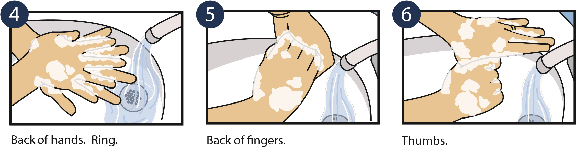

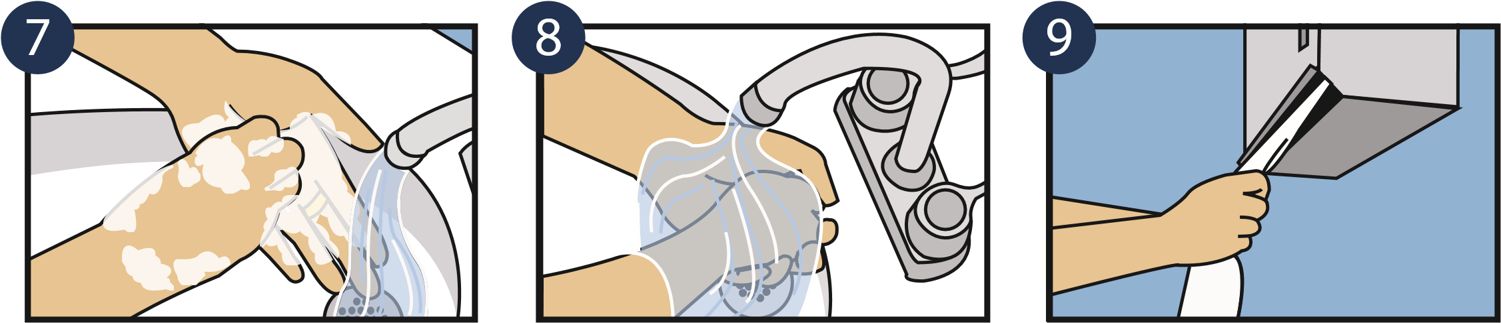

10

Turn off water with paper

towel.

Rinse with clear, running

water.

12

11

Fingertips.

Dry thoroughly with clean

paper towel.

Dispose of paper towel in a

hands-free trash can.

Open rest room door with

paper towel.

To purchase posters, email: Posters@CCAforSocialGood.com © 2012 CCA Global Partners, Inc.

Is your child well enough to be at school today?

Use this guide to help you determine when to send your child to school:



**Needs to STAY HOME**

**Check with teacher**

**Have a great day at school!**

* Fever over 100.4 degrees
* Open/infected sore not easily covered
* Vomiting
* Diarrhea
* Lice
* Red eyes with discharge
* Loss of taste or smell

** **Your child must be free from ANY *vomiting, diarrhea, or fever* for 24 HOURS without the aid of medications before returning to school.**\*\*

* Runny nose
* Cough
* Rash
* Been to the doctor, hospital, or ER
* Is not acting like usual
* Family member that is ill
* Feeling well today
* Has been feeling well and fever free for 24 hours ***WITHOUT*** the use of fever reducing medication

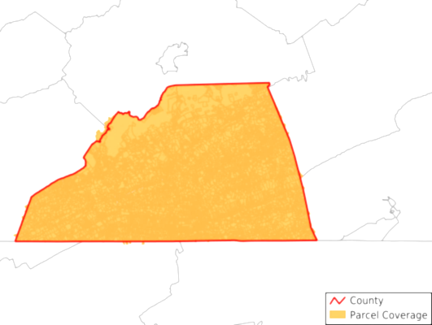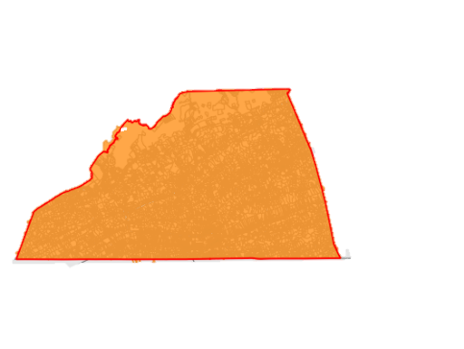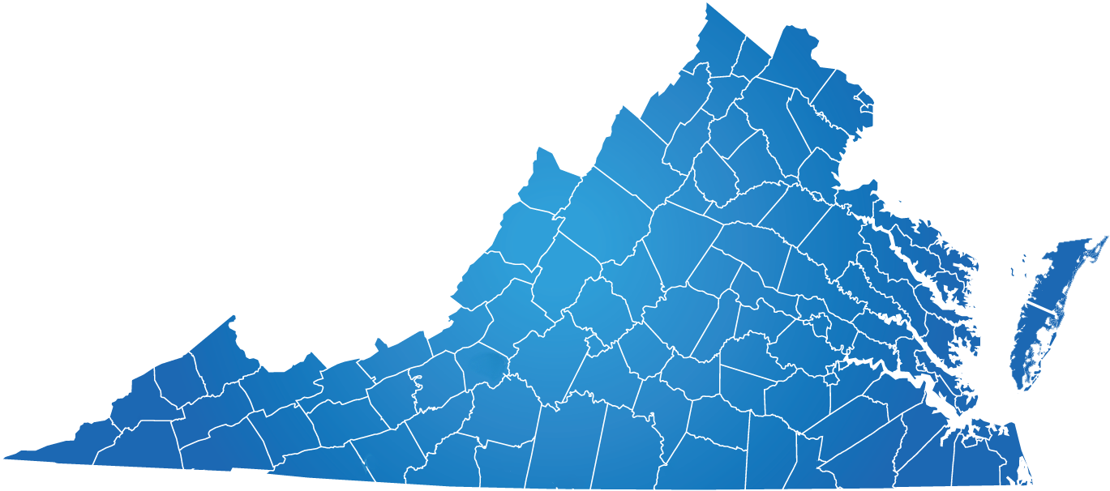

COVID-19

Community Level is

LOW



LOW

COVID-19

Community Level is LOW

COVID-19

Community Level is

MODERATE



HIGH

COVID-19

Community Level is LOW